Formula Student East Evening Storage Documentation

ver. 1.0
TABLE OF CONTENTS
ESD 1 General Information 4
ESD 1.1 Evening Storage 4
ESD 1.2 How To Use This Document 4
ESD 1.3 Evening Storage Container Requirements 4
ESD 1.4 ESD Requirements 5
ESD 1.5 Recommended Design 5
ESD 2 Template 6
ESD 2.1 General Information 6
ESD 2.2 General Concept 6

Changelog
Rule | Version | Change
 | 1.0 | Initial release
Abbreviations
ESD | Evening Storage Documentation
ESC | Evening Storage Container
TSAC | Tractive System Accumulator Storage

General Information

Evening Storage

As written in the FS East 2024 Competition Handbook EA 1.11 storing the TSAC in the pits during the evening is prohibited. This document contains the requirements of this container and provides a template for the Evening Storage Documentation.

Depending on the facilities of the venue FS East reserves the option to also accept the team’s trailer that is used to ship the TSAC to the competition as the team’s Evening Storage Container.

How To Use This Document

This document has been divided into two sections. The first section contains general information regarding the Evening Storage and is to be deleted before the ESD is uploaded to the login.feast.eu website.

ESC Requirements

The ESC must be waterproof in case of heavy rain. Openings that are not properly sealed can only face to the ground.

The opening through which the TSAC is moved in and out of the ESC must be properly sealed. It must have a closing mechanism that can be sealed by officials during the event.

Completely closed and/or sealed ESCs must have an overpressure relief.

The TSAC must be stored at least 100 mm above the ground inside the ESC.

The ESC must be rigid and sturdy.

The ESC must be stable enough to withstand strong wind.

In case of multiple TSACs the team must provide protection for each one of them. One ESC can contain more than one TSACs at the same time.

The following data must be visible on the ESC:

Car number

ESO name and phone number

Follow the formatting guidelines according to EV 5.3.8 in FS Rules 2024.

The ESC must be visible during the evening even in bad lightning conditions. The ESC must have a surface on each side that can reflect light (reflective tape, paint, etc.).

The worst-case weather conditions that are unlikely but the protection of the TSAC should be designed to withstand in case any of these occur:

100-120 km/h wind

Heavy rain

Water stagnation up to 100 mm

Hailstorm

It is the team’s responsibility to protect their TSAC during the evening from the conditions listed in ESD 1.3.7.

ESD Requirements

The ESD must provide evidence that the ESC is fully compliant with ESD 1.3.

None of the sections of the template can be left empty.

The maximum length of the ESD is 3 pages.

The ESC must be fabricated in accordance with the materials and processes described in the document. In the case of a bought container the datasheet must be provided.

If the team chooses to rent a place in a 20-foot container then the respective information must be provided in Table 1.

Recommended Design

We recommend that the teams design a metal enclosure that:
- Has a side that can function as a door so the handcart can be easily pushed in or pulled out.
- Is sealed along its edges but has a small opening so that high pressure can’t build up inside in case of a battery fire.
- Has flanges or similar at its bottom so it stands as stable as possible. We also recommend that the TS Accumulators while on the handcart are covered with the insulating blankets. Simplified example of the recommended design:
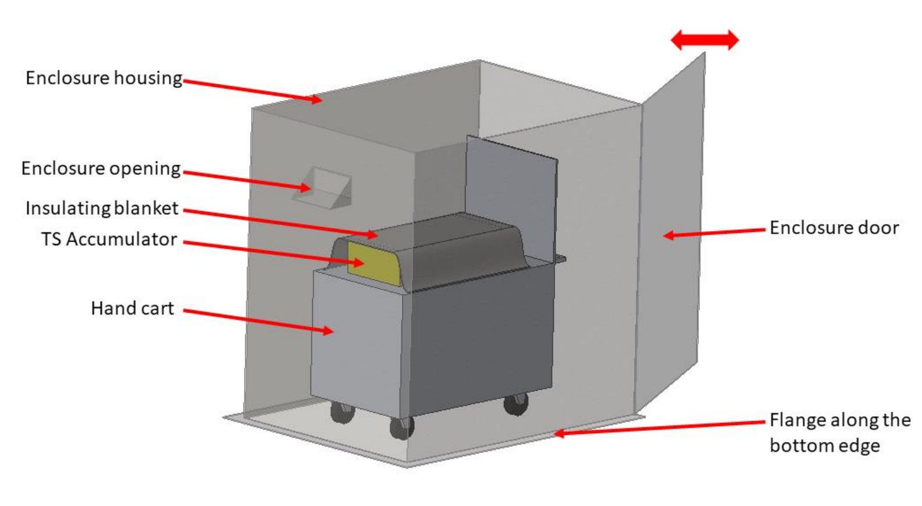

Template

General Information
Team Name
Car Number
ESO Name
ESO Phone Number
Number of TSACs
TSAC Dimensions (mm)
ESC Dimensions (mm)
Bought / Self-Built / Rented
Datasheet for bought ESC - Optional

Table 1.: General Information

You can use this space to provide additional general information about your ESC.

General Concept
Please provide here the general concept of your ESC:
- Figure about the ESC with main dimensions (3D model or the final product).
- Describe the used materials and structure of the ESC.
- General concept of the openings of the ESC and their sealings.
- Provide calculation for the wind speed that would be able to tilt or move your ESC.

Appendix
Use the Appendix to provide supporting datasheets, figures, and calculations to prove that your design is compliant with the points listed in ESD 1.

