Attention! From this year, the FS East ESF will change in a structural manner. The whole document is splitted into 6 nearly equal Sections. The sections must be uploaded separately.
Requirements
Read the document “How to complete ESF” which is available at:
https://www.fsaeonline.com/content/How-to-Complete-ESF.pptx
Maximum number of pages for a Section is 20 pages without the Appendix.
Each section must have its own Table of contents.
The table of contents must be hyperlinked.
The generated PDF must contain hyperlinked bookmarks.
Link to different sections are prohibited. If you have to refer to a part from a different Section, copy the necessary information instead. If you have to refer to a part in the same Section, the links must be hyperlinked, and there must be a link back to the original place.
Example: in chapter 2.1.2 you refer to chapter 2.4.1. By clicking on the text ”2.1.2” must jump to 2.4.1. At chapter 2.4.1 there must be a similar link back to 2.1.2.
Use internal reference links. For example, when describing wiring and mentioning a figure in the text then link it to the figure.
Links to video or audio data are prohibited.
If you did not fill out the tables or if you changed the format of the ESF Template, you will fail by default.
Every single part/heading of the ESF Template must be filled with content. If the respective part is not relevant for your concept, describe shortly why not.
Do not just copy all your datasheets in the appendix, e.g. we do not need to know what you must do to program your motor controller; we do not need the whole user manuals of microcontrollers to review your ESF, etc. Similarly, do not just paste only a link to the entire data sheet. We should not need an internet connection to obtain the information necessary to review your ESF.
Single pages/figures/tables extracted from the complete datasheet showing the important parameters, figures, etc. are usually sufficient, but the source/link to the complete datasheet must be provided.
If the datasheet describes more than one type of the component, clearly mark in the datasheet to which type you are referring / which type you plan to use.
Example: You copy a datasheet describing a complete range of relays. If you selected the 24V SPDT monostable version, you must highlight the information referring to this specific version.
Datasheets should only be used as a reference. Please cover the important data in your text by using tables, figures, etc.
If you refer to parts of a data sheet, then you need to provide an internal document links from the text to the respective datasheet and another internal document link back from the datasheet to the text section.
If you are unsure with respect to feedback of the reviewer, do not hesitate to write an e-mail and ask.
Parts of the ESF which are changed because of reviewer’s feedback must be marked in red.

Creating hyperlinks/cross-references
In order to comply with the requirements of the ESF, you will need to create some hyperlinks. Select References / Cross-reference in the Menu, then the following window will pop up. Set up the options as can be seen below, and choose the item, that you want to refer to.
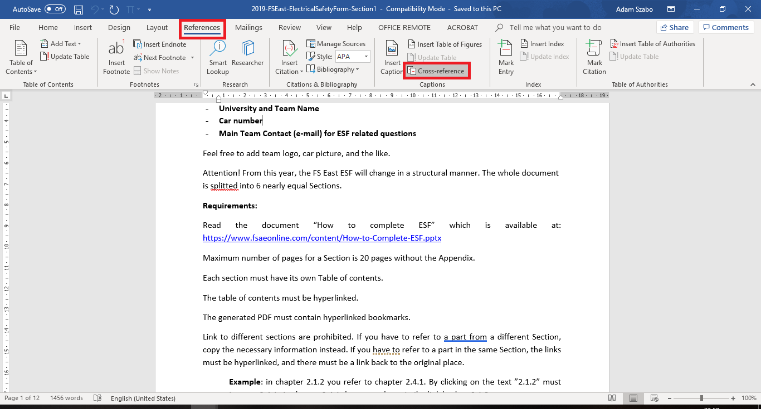
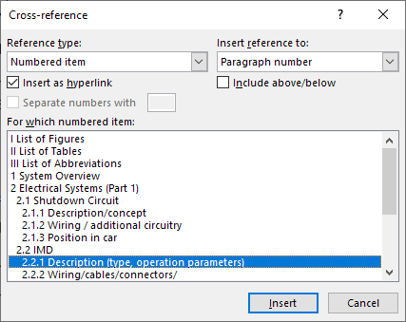
Creating bookmarks for PDF output
Print to PDF features usually does not support creating bookmarks from headings. If you used the provided Template, all the chapters have the proper Heading settings. Instead printing to PDF, select Save As, PDF (*.pdf) and More options…
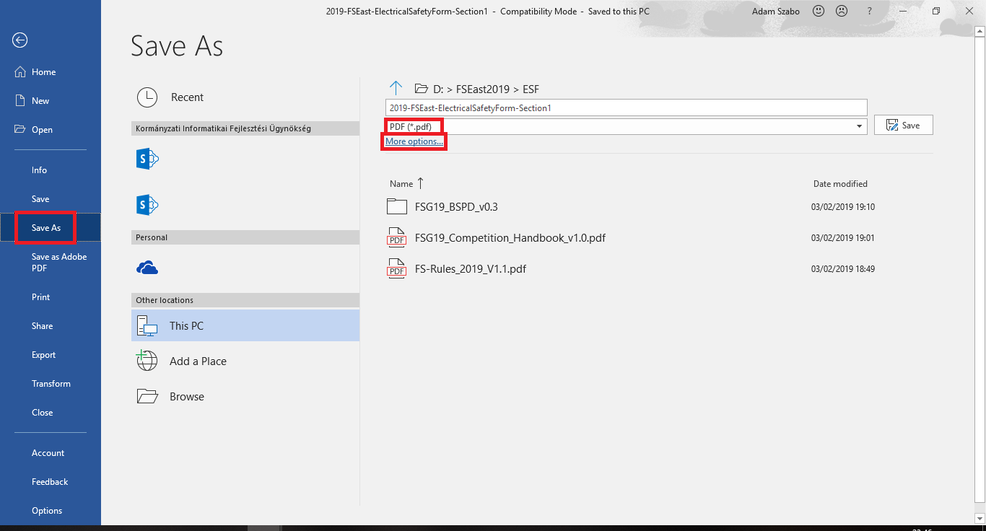
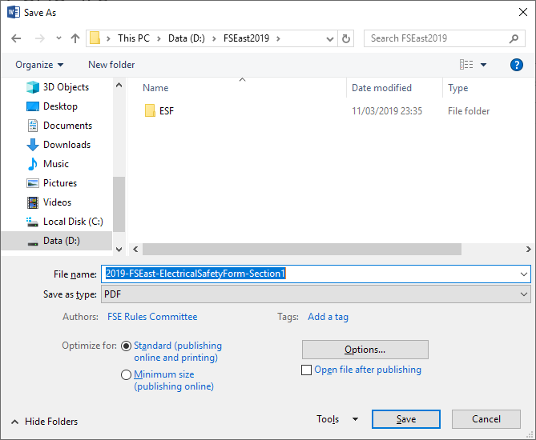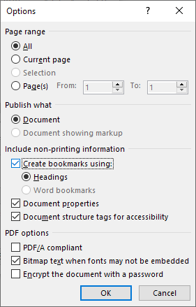
When you see the following pop-up window, choose the Options… button and check the Create bookmarks using: Headings, and you are done.

