Coversheet
The Coversheet must contain the following:
- Heading “Autonomous System Form FSEast 2018”
- University and Team Name
- Car number
- Main Team Contact for ASF related questions
Feel free to add team logo, car picture, and the like.
Requirements (delete this section after you have read and understood it):
Maximum number of pages for the complete ASF is 40 pages!
Links to video or audio data are prohibited.
If you did not fill out the tables or if you changed the format of the ASF Template, you will fail by default.
Every single part/heading of the ASF Template must be filled with content. If the respective part is not relevant for your concept, describe shortly why not.
The table of contents must be hyperlinked.
The generated PDF must contain hyperlinked bookmarks.
Use internal reference links. For example, when describing wiring and mentioning a figure in the text then link it to the figure.
Do not just copy all your datasheets in the appendix, e.g. we do not need to know what you must do to program your motor controller; we do not need the whole user manuals of microcontrollers to review your ASF, etc. Similarly, do not just paste only a link to the entire data sheet. We should not need an internet connection to obtain the information necessary to review your ASF.
Single pages/figures/tables extracted from the complete datasheet showing the important parameters, figures, etc. are usually sufficient, but the source/link to the complete datasheet must be provided. If the datasheet describes more than one type, clearly mark in the datasheet to which type you are referring / which type you plan to use.
Datasheets should only be used as a reference. Please cover the important data in your text by using tables, figures, etc.
If you refer to parts of a data sheet, then you need to provide an internal document links from the text to the respective datasheet and another internal document link back from the datasheet to the text section.
For example a link in the motor controller section “The datasheet can be found here (clickable)” and a link above the motor controller datasheet in the appendix “The section covering the motor controller can be found here (clickable)”.
If you are unsure with respect to feedback of the reviewer, do not hesitate to write an e-mail and ask.
Parts of the ASF which are changed because of reviewer’s feedback must be marked in red.
Following these guidelines will guarantee a swift review process.
- Table of Contents
I List of Figures 5
II List of Tables 6
III List of Abbreviations 7
2 System Overview 8
2.1 List of AS parts 8
2.2 Location of AS parts 8
3 Autonomous System Implementation 9
3.1 State Transition Table 9
3.2 State Transition Description 9
3.3 EBS Transitoin Description 9
4 Emergency Brake System 10
4.1 System Overview, Renderings, and Wiring Diagrams 10
4.1.1 List of used parts 10
4.1.2 Vehicle overview and EBS components positions 10
4.1.3 Operation description 10
4.1.4 Mechanical Parts 10
4.1.5 Electrical Wiring Diagram 10
4.1.6 Pneumatic/Hydraulic Systems 10
4.1.7 Schematics of hard wired EBS logic and latches 10
4.2 Descriptions 10
4.2.1 Functional Description 10
4.2.2 Functional Safety 11
4.2.3 System Critical Signals 11
4.2.4 Hardwired logic 11
5 Service Brake (if used) 12
5.1 System Overview, Renderings, and Wiring Diagrams 12
5.1.1 List of used parts 12
5.1.2 Vehicle overview and service brake components positions 12
5.1.3 Operation description 12
5.1.4 Mechanical Parts 12
5.1.5 Electrical Wiring Diagram 12
5.1.6 Pneumatic/Hydraulic Systems 12
5.2 Descriptions 12
5.2.1 Functional Description 12
5.2.2 Functional Safety 13
5.2.3 System Critical Signals 13
6 Steering System 14
6.1 System Overview, Renderings, and Wiring Diagrams 14
6.1.1 List of used parts 14
6.1.2 Vehicle overview and steering system components positions 14
6.1.3 Operation description 14
6.1.4 Mechanical Parts 14
6.1.5 Electrical Wiring Diagram 14
6.2 Descriptions 14
6.2.1 Functional Description 14
6.2.2 Functional Safety 15
6.2.3 System Critical Signals 15
7 ASSI Implementation 16
7.1 System Overview, Renderings, and Wiring Diagrams 16
7.1.1 List of used parts 16
7.1.2 Vehicle overview and ASSI components positions 16
7.1.3 Operation description 16
7.1.4 Mechanical Parts 16
7.1.5 Electrical Wiring Diagram 16
7.2 Descriptions 16
7.2.1 Functional Description 16
7.2.2 Functional Safety 16
7.2.3 System Critical Signals 16
8 Additional Autonomous Parts 17
9 Appendix 18

List of Figures

Has to be hyperlinked!

List of Tables
Has to be hyperlinked!

List of Abbreviations

System Overview
- Short description of the system’s concept
- Rough Schematic (blocks) showing all parts affected with the electrical systems and function of the tractive-system
- No detailed wiring

List of AS parts
Name | Role

Location of AS parts

Provide a top and side view of the vehicle showing the location of all AS components.

Autonomous System Implementation

State Transition Table
Provide a table showing the next state as well as the output for each state based on current input
Give a short overview about your AS State Machine implementation. Please do not just copy the rules diagram.

State Transition Description
Describe the "normal" race state transition sequence
Give a more detailed description of the state transitions, regarding your vehicle. (e.g. which control unit performs which check and how the result is communicated to the main CPU). A good way for this description is to imagine a race like acceleration. Describe what happens after switching on the ASMS until reaching the “AS-Finished” state from the view of the main CPU.

EBS Transitoin Description
Describe how the EBS state is entered.

Emergency Brake System

System Overview, Renderings, and Wiring Diagrams
Only show diagrams, drawings/renderings, and schematics here. All prosa text belong to the other sections. Make sure that all figures, as well as all components shown by these figures, are properly labeled to be referenced in other sections.

List of used parts
Name | Role

Vehicle overview and EBS components positions
Provide a side and top view of your vehicle and mark the positions of all EBS relevant components.

Operation description
A high level block diagram showing the interaction of all EBS relevant parts.

Mechanical Parts
Show renderings for all EBS relevant mechanical assemblies and parts. These renderings are used to understand the full mechanical interaction between e.g. the actuator and the brake pedal.

Electrical Wiring Diagram
Provide a detailed wiring diagram showing all EBS relevant parts. Use black boxes for the hardwired latching parts. The schematic must contain the SC, all master switches, communication interfaces, processing units and EBS relevant sensors. Diagrams showing more than the requested parts, e.g. the full vehicle, will be rejected.

Pneumatic/Hydraulic Systems
Provide a detailed diagram showing all EBS relevant pneumatic/hydraulic systems.

Schematics of hard wired EBS logic and latches
Provide a full schematic for the hard wired logic. Use the interface shown in the electrical wiring diagram. Make sure to use ambiguous names.

Descriptions

Functional Description
Describe your implemented EBS solution and how the braking action is done. All diagrams, overall renderings, and schematics shown in the previous section have to be explained here in a way to understand the functionality. Describe how you apply DV3.1.3, DV3.1.6
To describe the normal function its the easiest way to imagine a EBS triggered by RES. Start your description with the opening of the RES relays and describe the interaction of all involved components down to the wheels. (Reference all components to the schematics in the previous section by unique names).

Functional Safety
Show how you ensure the functional safety required by the rules.
"All safety or system critical things belong here. Ensure that you show:
how the EBS gets activated (DV2.4.8),
how functionality of the EBS is ensured (DV3.2.1),
how the EBS is monitored for failures (if necessary) (DV3.2.1),
how the EBS is triggered if monitoring system fails (if monitoring is necessary) (DV3.2.1),
how the to way monitoring with the service brake is done (if used as redundancy) (DV3.2.5),
how the EBS is checked to be fully functional on deactivated to available transition (DV2.4.1),
that the EBS cannot be triggered in manual mode (DV2.2.5 point 5)

System Critical Signals
Describe in a detailed way how you implement the system critical signals requirements. Use signal classes/groups whenever its applicable.

Hardwired logic
Explain in a detailed way how the latching is done. Ensure that the reset action has less priority compared to the set action.

Service Brake (if used)
If a service brake is not used, this section can be skipped.

System Overview, Renderings, and Wiring Diagrams
Only show diagrams, drawings/renderings, and schematics here. All pros belong to the other sections. Make sure that all figures, as well as all components shown by these figures, are properly labeled to be referenced in other sections.

List of used parts
Add all major parts used within the service brake
Name | Role

Vehicle overview and service brake components positions
Provide a side and top view of your vehicle and mark the positions of all service brake relevant components.
This drawings will be used during technical inspection to easily identify all service brake parts. If locations are changing, please bring updated (marked as such!) drawings to tech inspection.

Operation description
A high level block diagram showing the interaction of all service brake relevant parts.

Mechanical Parts
Show renderings for all service brake relevant mechanical assemblies and parts.

Electrical Wiring Diagram
Provide a detailed wiring diagram showing all service brake relevant parts.
The schematic must contain all master switches, communication interfaces, processing units and sevice brake relevant sensors. Diagrams showing more than the requested parts, e.g. the full vehicle, will be rejected.

Pneumatic/Hydraulic Systems
Provide a detailed diagram showing all service brake relevant pneumatic/hydraulic systems.

Descriptions

Functional Description
Describe your implemented service brake solution and how the braking action is done. All diagrams, overall renderings, and schematics shown in the previous section have to be explained here in a way to understand the functionality.

Functional Safety
Show how you ensure the functional safety required by the rules. All safety or system critical things belong here. Especially when the service brake is used as EBS redundancy.

System Critical Signals
Describe in a detailed way how you implement the system critical signals requirements. Use signal classes/groups whenever its applicable.

Steering System

System Overview, Renderings, and Wiring Diagrams
Only show diagrams, drawings/renderings, and schematics here. All pros belong to the other sections. Make sure that all figures, as well as all components shown by these figures, are properly labeled to be referenced in other sections.

List of used parts
Add all major parts used within the Steering System
Name | Role

Vehicle overview and steering system components positions
Provide a side and top view of your vehicle and mark the positions of all steering system relevant components.
This drawings will be used during technical inspection to easily identify all steering system parts. If locations are changing, please bring updated (marked as such!) drawings to tech inspection.

Operation description
A high level block diagram showing the interaction of all steering system relevant parts.

Mechanical Parts
Show renderings for all steering system relevant mechanical assemblies and parts.
These renderings are used to understand the full mechanical interaction between e.g. the actuator and the manual steering system of the base vehicle

Electrical Wiring Diagram
Provide a detailed wiring diagram showing all steering system relevant parts. Use black boxes for the hardwired latching parts.
The schematic must contain all master switches, communication interfaces, processing units and steering system relevant sensors. Diagrams showing more than the requested parts, e.g. the full vehicle, will be rejected.

Descriptions

Functional Description
Describe your implemented steering solution and how the steering action is done. All diagrams, overall renderings, and schematics shown in the previous section have to be explained here in a way to understand the functionality

Functional Safety
Show how you ensure the functional safety required by the rules.
All safety or system critical things belong here.

System Critical Signals
Describe in a detailed way how you implement the system critical signals requirements. Use signal classes/groups whenever its applicable.

ASSI Implementation

System Overview, Renderings, and Wiring Diagrams
Only show diagrams, drawings/renderings, and schematics here. All pros belong to the other sections. Make sure that all figures, as well as all components shown by these figures, are properly labeled to be referenced in other sections.

List of used parts
Add all major parts used within the ASSI
Name | Role

Vehicle overview and ASSI components positions
Provide a side and top view of your vehicle and mark the positions of all ASSI relevant components.
This drawings will be used during technical inspection to easily identify all ASSI parts. If locations are changing, please bring updated (marked as such!) drawings to tech inspection.

Operation description
A high level block diagram showing the interaction of all ASSI relevant parts.

Mechanical Parts
Show renderings for all ASSI relevant mechanical assemblies and parts.

Electrical Wiring Diagram
Provide a detailed wiring diagram showing all ASSI relevant parts. Use black boxes for the hardwired latching parts.

Descriptions

Functional Description
Describe your implemented ASSI solution. All diagrams, overall renderings, and schematics shown in the previous section have to be explained here in a way to understand the functionality.

Functional Safety
Show how you ensure the functional safety required by the rules. All safety or system critical things belong here.

System Critical Signals
Describe in a detailed way how you implement the system critical signals requirements. Use signal classes/groups whenever its applicable.

Additional Autonomous Parts
Anything else you think it is worth to mention….

Appendix

Numbering according to chapter 1 to 6
A datasheet for motor controller one for example has to have the numbering 11.10.5
Example appendix entry:
11.2.2 – Bender IR155-3203 IMD ratings
Referred from 2.1.1.
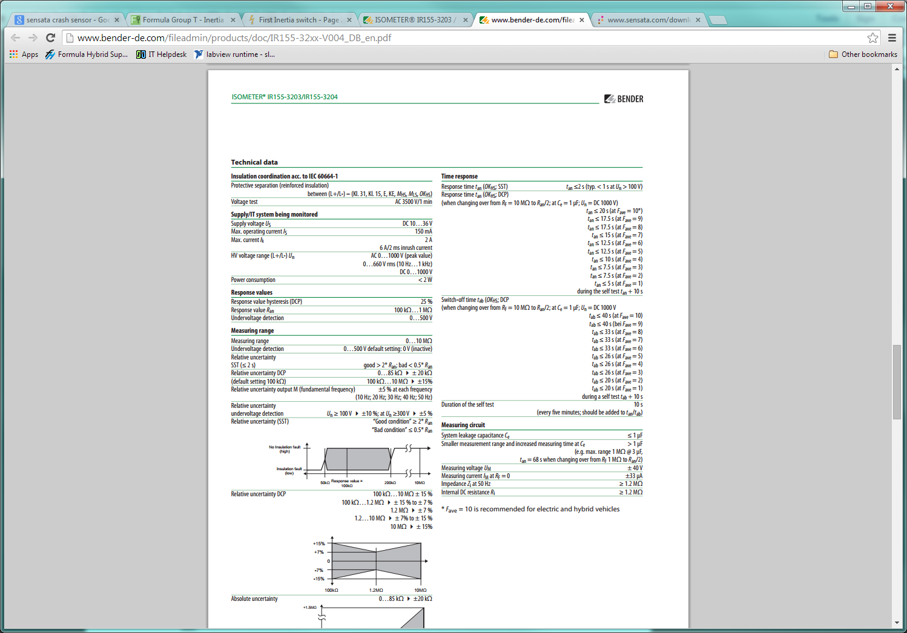
Complete data sheet located at:
http://www.bender-de.com/fileadmin/products/doc/IR155-32xx-V004_DB_en.pdf

